Usefull link:- https://devdungeon.com/content/text-speech-python-pyttsx3

# using pyttsx3 module

#pip install pywin32 pypiwin32 pyttsx3

After pip install pywin32==225 I am getting builtins.ImportError: DLL load failed: The specified procedure could not be found

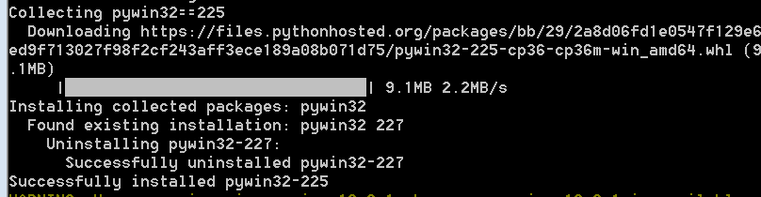

So, I reinstalled pip install pywin32==227…and it worked fine.

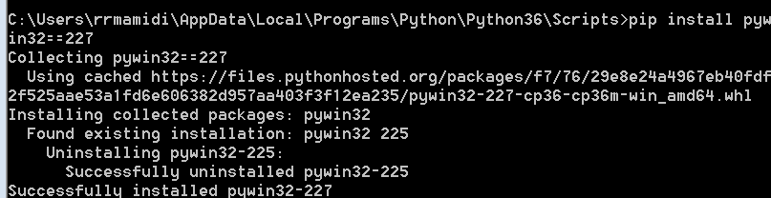

# sample code for text-to-speech using Pyttsx3 is an **offline cross-platform Test-to-Speech** library which is compatible with both **Python 3 and Python 2** and supports multiple TTS engines. Prefer to use pyttsx3 module.

import pyttsx3

engine = pyttsx3.init()

engine.setproperty(‘rate’,150) # Speed percent (can go over 100)

#engine.setProperty('volume', 0.9) # Volume 0-1

engine.say('Good morning.') # test to speech in audio.

#Flush the say() queue and play the audio.

engine.runAndWait()

#Below code is to get voices available

import pyttsx3

engine = pyttsx3.init()

# below code is to get vioces availabe

voices =engine.getProperty('voices')

for voice in voices:

print("Voice:")

print(" - ID: %s" % voice.id)

print(" - Name: %s" % voice.name)

print(" - Languages: %s" % voice.languages)

print(" - Gender: %s" % voice.gender)

print(" - Age: %s" % voice.age)

# output :-

Voice:

- ID: HKEY_LOCAL_MACHINE\SOFTWARE\Microsoft\Speech\Voices\Tokens\MS-Anna-1033-20-DSK

- Name: Microsoft Anna - English (United States)

- Languages: []

- Gender: None

- Age: None

Voice:

- ID: HKEY_LOCAL_MACHINE\SOFTWARE\Microsoft\Speech\Voices\Tokens\MS-Lili-2052-20-DSK

- Name: Microsoft Lili - Chinese (China)

- Languages: []

- Gender: None

- Age: None

# Below code is to speech in different audio.

import pyttsx3

engine = pyttsx3.init()

# These will be system specific

en_voice_id = 'HKEY_LOCAL_MACHINE\SOFTWARE\Microsoft\Speech\Voices\Tokens\MS-Anna-1033-20-DSK'

chinese_voice_id = 'HKEY_LOCAL_MACHINE\SOFTWARE\Microsoft\Speech\Voices\Tokens\MS-Lili-2052-20-DSK'

# English language

engine.setProperty('voice',en_voice_id) # to deliver in particuar voice

engine.setProperty('rate', 150) # Speed percent (can go over 100)

engine.setProperty('volume', 0.9) # Volume 0-1

engine.say('Good Morning.')

engine.runAndWait()

# chinese language

engine.setProperty('voice',en_voice_id) # to deliver in particuar voice

engine.setProperty('rate', 150) # Speed percent (can go over 100)

engine.setProperty('volume', 0.9) # Volume 0-1

engine.say('Zǎoshang hǎo')

engine.runAndWait()

# sample code for text-to-speech using win32com.client **offline cross-platform Test-to-Speech** library

import win32com.client

speaker = win32com.client.Dispatch("SAPI.SpVoice")

#speaker.Speak("Jumpman Jumpman Jumpman Them boys up to something!")

speaker.Speak('Good morning.')